GRADE 11

November Exam
HISTORY
3 Hours 200 marks
NAME:………………………………………………… KEY:……..
EXAMINER: MR. D EDWARDS
MODERATOR: MRS. J MOGG
INSTRUCTIONS:
This paper consists of 9 pages, excluding the cover page.
The source booklet consists of 6 pages, excluding the cover page.
You are to answer all questions in the exam booklet provided.
Start each section on a new page.
Make sure your answers are clearly written.
Time yourself and do not spend too much time on one question and too little on another.
The exam paper consists of 3 sections:
Section 1 – Single Source Analysis /60
Section 2 – Multiple Source Questions /90
Section 3 – Source Based Essay /50
TOTAL: /200
SECTION 1 – SINGLE SOURCE ANALYSIS
SOURCE 1

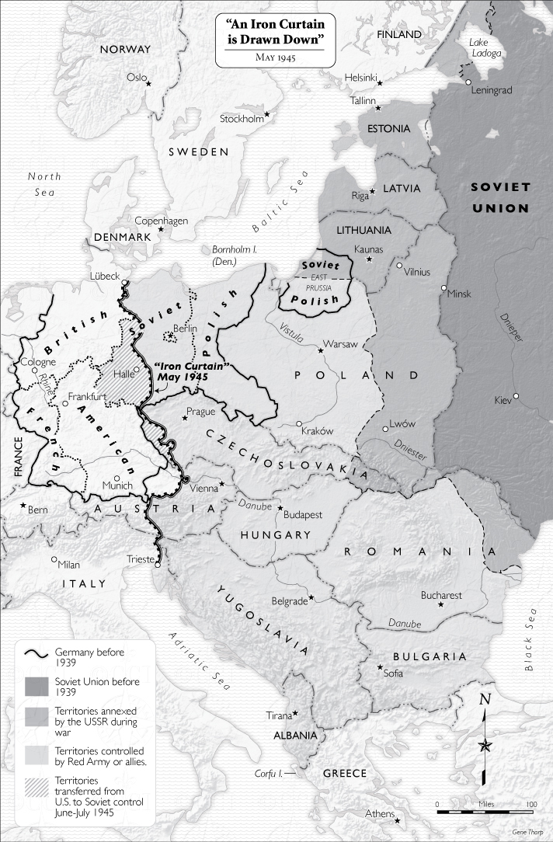

1. 1. The Iron Curtain was not literally a curtain of iron. What was it and why do you think it was a suitable name? (6)
1. 2. What was the economic and political difference between the countries in the west and the countries in the east? (4)

1. 3. Explain the difference between land annexed by the Soviet Union, and other countries where Soviet communism was imposed. (4)

1. 4. Yugoslavia had adopted a communist system, but differed from other communist countries. How can you tell this from the map? (2)
1. 5. Suggest reasons why Stalin insisted that East Prussia, which had been part of Germany, was incorporated into either Poland or the USSR. (4)

(20)

SOURCE 2
“As your President, I pledge that I shall always uphold that proud bipartisan tradition. Standing in this Convention Hall 4 years ago, I pledged to seek an honorable end to the war in Vietnam. We have made great progress toward that end. We have brought over half a million men home, and more will be coming home. We have ended America's ground combat role. No draftees are being sent to Vietnam. We have reduced our casualties by 98 percent. We have gone the extra mile, in fact we have gone tens of thousands of miles trying to seek a negotiated settlement of the war. We have offered a cease-fire, a total withdrawal of all American forces, an exchange of all prisoners of war, internationally supervised free elections with the Communists participating in the elections and in the supervision.

There are three things, however, that we have not and that we will not offer. We will never abandon our prisoners of war. Second, we will not join our enemies in imposing a Communist government on our allies - the 17 million people of South Vietnam. And we will never stain the honor of the United States of America.”

R. Nixon speech to Republican National Convention, Aug. 23, 1972.

2. 1. What measures has the USA gone to in their attempts to negotiate a settlement of the war? (4)

2. 2. Define the term ‘Vietnamisation’. (3)

2. 3. Why does President Nixon state, “there are three things, however, that we have not and that we will not offer”? Explain with reference to your own knowledge. (4)

2. 4. Why is it significant that no draftees are being sent to Vietnam? Justify your answer in full. (4)

2. 5. Would you consider this source to be reliable for a Historian studying the Vietnam War? Explain your answer. (5)

(20)

SOURCE 3
“Like I said, I really don’t have a memory of getting engaged in it that much. I remember conversations about McCarthy, and McCarthyism, and Communism, and some degree of understanding of what he had done to other people’s lives. But we weren’t really a political family. We really didn’t get into the discussions about any of this. It was more about being concerned about whether you were going to be drafted or whether you should enlist rather than the geo-political situation. I had a choice. I mean I didn’t have a choice. You’re going to get drafted. So either you’re going to get drafted or you’re going to choose a path. I had pretty high battery test scores. So I went to the Navy. They actually wanted me to sign me up for an additional two years to go into nuclear. I said, “You have four years. I’ll be glad to go but I’m not giving you two more years of my life.” That much I knew. I was pretty strong about. If I had a choice, I didn’t want to go. I don’t think I had any. There was no sense of duty to the country. It was more like an obligation that I have to go and do this thing. It’s like most vets. They really don’t want to talk about it generally.
This is what it is for vets. This is why they’re homeless, generally. I’m convinced of this. We want to go home. Home is what I grew up with honesty, integrity, a sense of principals, and so forth. And these conflicts are not. And you come out the other side and you try to go back home and you can’t. You try to address that and you can’t. I can’t go home now. I tried to talk to my family and my sister and I don’t even talk anymore. Because I can’t let go of this until there is justice. I was part of a war machine that slaughtered five-million people, which seems like such a stupid thing to say. I mean, I can’t wrap my head around that. When you melt it down to a child and a mother and then they’re gone, they’re in a field and then they’re gone. And that means nothing to us? Even today that means nothing to us.“
An interview conducted in February 2012 with American Vietnam War Veteran Joseph LaBonte. Joseph was drafted in 1968 and worked on an aircraft carrier from 1969-1972. He explains his anger after the war and his personal journey in dealing with resentment.

3. 1. Define the historical term ‘Communism’. (2)

3. 2. Why were young people in America concerned with the draft? (2)
3. 3. According to La Bonte, did most people feel proud to be going to the Vietnam War? Explain your answer with reference to the source. (3)

3. 4. What impression of the Vietnam War does La Bonte provide? Provide 3 quotes when justifying your answer. (6)

3. 5. Is La Bonte in support of America’s involvement in the Vietnam War? Justify your answer in full. (4)

3. 6. Is this source useful to a Historian studying the Vietnam War? Explain your answer with reference to the source. (3)

(20)

[TOTAL: 60]

SECTION 2 – SOURCE BASED QUESTIONS
Explain the following historical concepts:
1. Détente (2)
2. Policy of Containment (2)
3. Socialism (2)
Refer to Source A
4. List 4 things that the ‘Truman Doctrine’ is against. (4)
5. Why does General George C. Marshall think the “world situation is very serious”? (3)
Refer to Source B
6. Provide one visual clue that America is being altruistic (showing a disinterested and selfless concern for the well-being of others). (2)
7. Does the cartoonist agree with the Marshall Plan? Explain your answer with reference to the source. (4)
Refer to Source A and B
8. How do Sources A and B send the same message? Make reference to the source when justifying your answer. (4)
Refer to Source C
Answer the following questions with True or False as your answer.
9.1. Marshall Aid was motivated by only self-interest on America’s part. (2)
9.2. Truman was motivated by the Hitler’s aggression in 1930s when setting up the Marshall Plan. (2)
9.3. Marshall Aid was intended to create wealthy countries that could export their good to America. (2)
9.4. Stalin felt Marshall Aid was America’s attempt to control countries by making them dependant on trade and American skills. (2)
9.5. Stalin was optimistic and positive about the Marshall Aid at its inception. (2)
Refer to Source D
10. Does Andrei Vyshinsky think the Truman Doctrine and the Marshall Plan are positive/good strategies? Provide evidence from the source to substantiate your answer. (4)
Refer to Source A and D
11. Why do the interpretations of the Truman Doctrine and the Marshall Plan differ in Source A and Source D? (4)

Refer to Source F
Answer the following questions with True or False as your answer.
12.1. The Marshall Plan was offered to all countries under communist threat. (2)
12.2. Sixteen countries were given $13,150,000,000 each to help rebuild. (2)
12.3. The Soviet Union considered taking Marshall Aid before July 1947. (2)
12.4. The Berlin Conference was where Molotov rejected the Marshall Plan. (2)
12.5. Hungary, Poland and Czechoslovakia took aid from the Marshall Plan despite disapproval from the USSR. (2)
Refer to Source E and G
13. What is the cartoonist’s (Source E) opinion of the Marshall Plan? Provide evidence from the source to justify your answer. (4)
14. What can we learn about President Truman from Source G? (3)
15. How do Sources E and G differ in their message? Refer to the sources to substantiate your answer. (4)
Refer to Source H and I
16. How is America portrayed in Source H? Provide a quote to substantiate your answer. (3)
17. Who does the author of Source I feel is to blame for the Berlin Crisis? Justify your answer with one quote from the source. (2)
18. How and why do these sources differ in their interpretation of America’s actions? (8)
19. Which source do you consider to be more reliable? Justify your answer with reference to both sources. (5)
Refer to Source J
20. Explain the phrase, “Who’s next to be liberated from Freedom, Comrade?”
(3)
21. Why is Stalin about to pull down France’s switch? Explain with reference to your own knowledge. (3)
22. Explain the message of the cartoon. (4)
[TOTAL: 90]

SECTION 3 - SOURCE BASED ESSAY

Answer the following essay question.

“The Marshall Plan was a selfless intervention introduced by America with Europe’s best interest at heart”.
Discuss the validity of this statement using the sources as evidence.

A reminder:
- Make sure your essay’s introduction indicates the argument.
- Include a counter-argument.
- Use every source.
- Write a conclusion that sums up the entire essay.

[TOTAL: 50]

